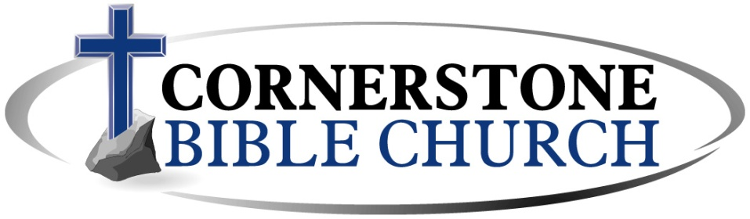

Cornerstone Family,
Many things have been developing over the last few weeks: the President declared a national emergency, major conferences have been shut down, colleges and schools are closing, and the CDC stated “organizations that serve people who are at higher risk for COVID-19 illness, cancel events for groups of 10 people or more.” So, how should the church respond?
The bible teaches that it is God who establishes the governing authorities and it is the responsibility of every believer to submit to them (Romans 13:1-7). As our president, governors, and medical professionals across the country do their best to stop the spread of the coronavirus, the Elders of Cornerstone Bible Church believe that we should honor the request to “cancel events” (in some states its mandatory) that draw crowds of 10 or more, especially those events containing older people who seem to be suffering the most from this virus.
With that being said, Sunday services will be canceled until further noticed. We do not have a specific time frame to share with you because so much of this information is developing on a daily basis. We will continue to watch closely for more information in the days and weeks to come as we do our best to shepherd the church during this critical time.
Please pray for the leaders of our country as they navigate through this issue, the medical professionals who are working overtime to help those who are sick, and the church in general as the entire body of Christ across the nation is being affected by this as well.
I also want to encourage you, for those who are able, to continue to give faithfully to the church. While services may be canceled, unfortunately, the bills and ministry cost for the church still remain. There are two primary ways you can give during this time: 1) call the church office and schedule a time to stop by with your offering or 2) go to our website and click the “Giving” tab to give electronically. We trust the Lord and know without doubt that He will carry us through this unique time in our church’s life.
Finally, know that the Elders are looking for ways to serve you during this time. Please check our webpage for audio sermons and other information that will feed you spiritually in the weeks to come. May God bless you and strengthen you. May He give you wisdom as you navigate through any challenges you may be experiencing with these changes and may Christ be gloried as He faithfully shepherds His church through the coming days. With that in mind…wash your hands, stay healthy, cover your cough, and keep praying!

In Christ,
Pastor Matthew I. Sandorfi

